**User:**

I am a Mechanical Designer, proficient in SolidWorks drafting, and a recent graduate of the University of New South Wales. I would like you to act as both a knowledgeable designer who can provide me with design expertise and a professional engineering designer who can act as a technical advisor to me when I have complex questions.

I like the minimalist and sleek design style of the energy harvesting device. It should look clean and modern without unnecessary details.

The equipment must comply with Australian Standards for Electrical Equipment. The design should be compact to fit into the limited urban space where the installation is specified. Considering the budget of A$50,000, we should prioritise durable materials, balancing cost and longevity.

Based on the above background, I will be designing an energy harvesting device.

The energy harvesting device shall require three key modules:

1. The energy accumulation module functions to derive energy from an external source outside the energy harvesting device.

2. The energy storage module functions to store the accumulated energy inside the energy

harvesting device.

3. The energy utilization module utilizes the harvested energy to power other small devices such as sensors, heating/cooling devices, actuators, and low-power devices.

Please give me as many and reasonable and complete designs as possible.

**GPT:**

Designing an energy harvesting device based on your requirements and constraints is an exciting challenge. Let's break it down into key design considerations and conceptual ideas:

**Design Considerations**

1. **Compliance with Australian Standards for Electrical Equipment**: This is crucial for safety and legal reasons. We'll need to ensure the device meets these standards in terms of materials, electrical safety, and operation.
2. **Minimalist and Sleek Design Style**: The aesthetics should be clean and modern. This implies avoiding ornate details and focusing on functional elegance.
3. **Compactness for Urban Installation**: The design must be space-efficient to fit into limited urban spaces. This could mean a modular design or a vertical orientation to minimize footprint.
4. **Budget and Material Selection**: With a budget of A$50,000, the choice of materials must balance cost and durability. We should consider materials like high-grade plastics, aluminum, or stainless steel for their longevity and cost-effectiveness.
5. **Three Key Modules**:
   * Energy Accumulation Module: This could involve solar panels, wind turbines, or kinetic energy converters.
   * Energy Storage Module: This likely means batteries or supercapacitors.
   * Energy Utilization Module: This module should have versatile connections to power a range of devices.

**Conceptual Design Ideas**

1. **Modular Stack Design**: Each module (accumulation, storage, utilization) could be a separate stackable unit. This modular approach allows for easy maintenance and scalability.
2. **Integrated Solar Panel System**: For the energy accumulation module, integrating solar panels on the exterior surfaces can harness solar energy efficiently.
3. **Battery Pack with Monitoring System**: For energy storage, a battery pack with a smart monitoring system can optimize energy usage and ensure longevity.
4. **Versatile Output Ports**: The energy utilization module should have multiple output ports compatible with various devices, ensuring versatility.
5. **Cooling System**: Given the Australian climate, a passive or active cooling system to protect the electronics is essential.
6. **Robust Outer Casing**: A durable outer casing, possibly using a mix of aluminum and high-grade plastic, can protect the internal components from weather elements and urban wear and tear.
7. **Smart Connectivity**: Incorporating IoT capabilities for remote monitoring and management of the device's performance and energy levels.
8. **Ergonomic Maintenance Access**: Designing for easy access to internal components for maintenance and upgrades.

Considering these design considerations and ideas, you can start developing detailed designs using SolidWorks, focusing on each module's specifications and integration. Remember, the success of such a device lies in balancing functionality, cost, and aesthetics while adhering to safety and operational standards.

**User:**

Based on the scenario you gave me above, please generate a visual concept diagram.

**GPT:**

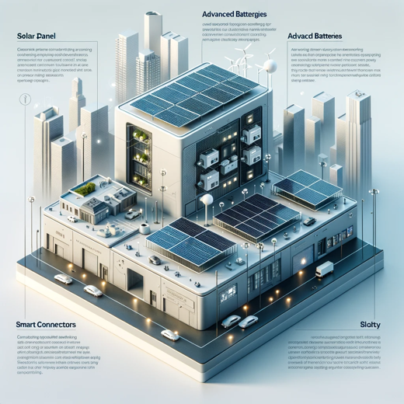

The visual concept diagram for the urban energy harvesting device is displayed above. It showcases the sleek and minimalist design, with the distinct modules for energy accumulation, storage, and utilization, along with the compact and robust construction suitable for an urban environment.